SAVEETHA SCHOOL OF ENGINEERING
SAVEETHA INSTITUTE OF MEDICAL AND TECHNICAL SCIENCES

PROGRAMMING ASSIGNMENT
Student Submission
Student Name | D Bharath
Register Number | 1972260104
Course Code & Name | Programming in C
Slot | A
Assignment / Task Title | Electricity Billing — Data Types, Constants and Macros (Tasks 1–4)
GitHub Repository URL | https://github.com/bharathdasaraju01-droid/CSA-0208-C-Programming.git
Submission Date | 27 October 2026

Instructions to Students
- Complete every section for each assigned task.
- Write your own explanation, algorithm/pseudocode, and program.
- Run the program and insert a clear screenshot of the output.
- Include test cases and a short analysis where applicable.
- If code is maintained on GitHub, provide the correct repository link.

TASK 1 — Understand the Problem and Identify the Data

Task / Problem Statement
Analyse the electricity billing problem and identify every item of data the program must store and compute: the inputs, outputs, constants, values that may be negative, fractional or very large, the rules every correct bill must satisfy, and the assumptions made. Each data item must be justified.

Aim
To analyse the billing problem systematically so that every data item, its role, and the rules for a correct bill are known before any code is written.

Concept / Theory
Before choosing variables, a programmer separates data into inputs (supplied by the user or meter), outputs (computed by the program), and constants (fixed by the tariff and never changed during a run). A meter shows a cumulative reading, so the units consumed are the difference between the current and previous readings. Money must be treated carefully: a binary floating-point number cannot represent most decimal fractions exactly (for example 0.1), so exact money values are better kept as whole numbers of the smallest unit (paise). A well-posed problem also states invariants — rules a bill must always satisfy — which later become validation checks and test cases.

Procedure / Algorithm
- Read the problem and list all values that enter the program (inputs).
- List all values the program must produce (outputs) and how each is derived.
- Mark values that never change during a run as constants.
- For every item, decide whether it can be negative, fractional or very large.
- Write the rules (invariants) every correct bill must satisfy.
- Record the assumptions made where the problem is silent.

Program / Source Code
This task is an analysis task, so no executable program is required. The data dictionary and the declarations that follow from it are given below.
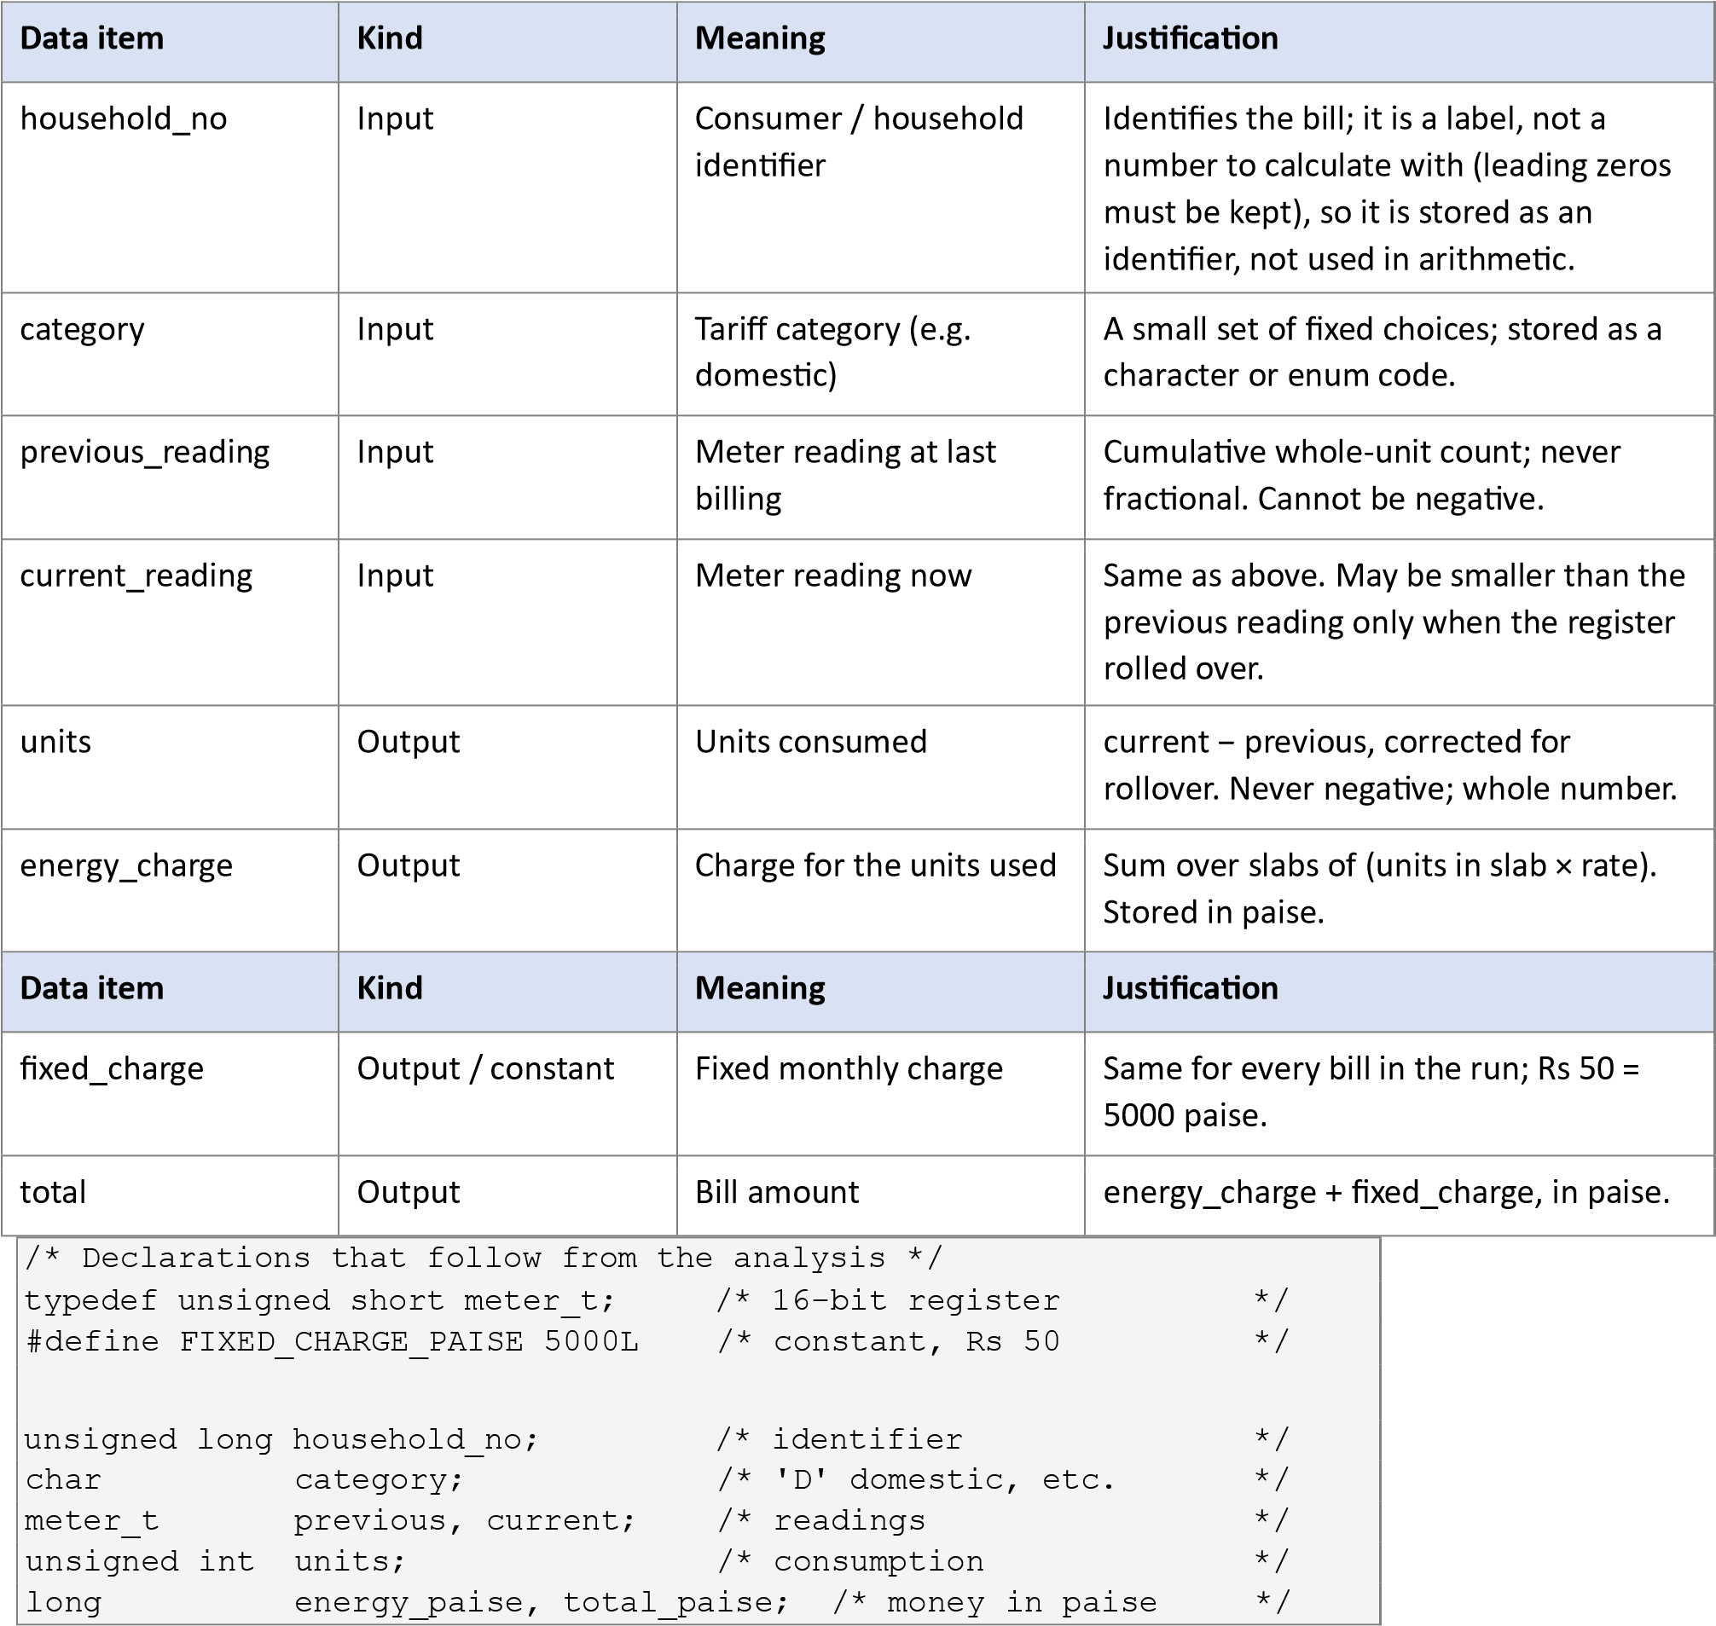
Output Screenshot
Not applicable — analysis task (no program output).

Analysis / Discussion
- Inputs and outputs. Inputs: household number, category, previous and current readings. Outputs:
units, energy charge, fixed charge and total. Only four items are typed in; everything else is computed, which keeps the program small and avoids inconsistent data.
- Constants. The slab limits (100, 200 units), the three per-unit rates, the fixed charge, and the register capacity (65535) never change during a run. They are defined once so a tariff revision is made in one place.
- Negative, fractional, very large. Negative: the raw difference current − previous is negative after a rollover, and a data-entry error could also give a negative value — this must be detected or corrected, but the final bill is never negative. Fractional: rates such as Rs 2.25 are fractional in rupees, which is why paise are used. Very large: the sum of bills for a district (lakhs of households, each up to thousands of rupees) can exceed the range of a 32-bit int, so district totals need a 64-bit type.
- Rules every correct bill must satisfy. (1) units ≥ 0; (2) bill ≥ fixed charge, so a bill is never negative; (3) total = energy_charge + fixed_charge; (4) the bill never decreases as units increase (monotonic); (5) the slab boundaries are continuous — the bill at 100, 200 units is the same whichever slab formula is used; (6) a zero-unit bill equals the fixed charge.
- Assumptions. The meter register is a 16-bit counter that wraps at 65535 and wraps at most once between two readings; readings are whole units; the slab tariff is 0 paise (first 100), 225 paise (101– 200), 450 paise (above 200) with a Rs 50 fixed charge; no tax or surcharge is applied; all money is in Indian rupees stored as paise.

Alternative Concept and Complexity Analysis
If the readings were read and stored as text (for example "01530") instead of integers, the program would hold char arrays and convert each to a number (atoi/strtol) before subtracting. Comparing them as strings is not enough, because "950" sorts after "1530" alphabetically, and a rollover cannot be detected without a numeric value.
 | Integer (unsigned short) | Text (char array, d digits)
Space per reading | 2 bytes (fixed, independent of d) | d + 1 bytes (d digits + the '\0'); "01530" uses 6 bytes. O(d)
Time to convert | None (already a number) | O(d): each digit is read once
Time to compare | O(1) — one machine comparison | O(d) as text, or O(d) conversion then O(1)
 | Integer (unsigned short) | Text (char array, d digits)
Error checking | Range fixed by type | Must validate characters are digits and length ≤ d
For a 5-digit reading, the text form uses 6 bytes against 2 bytes and costs about 5 digit operations per reading instead of none. The integer representation is therefore smaller and faster, and is the better choice when millions of readings are processed; text is useful only to preserve leading zeros for display.

Result
All inputs, outputs, constants, value ranges, bill rules and assumptions were identified and justified. This analysis directly drives the data types chosen in Task 2 and the constants defined in Task 3.

TASK 2 — Choose the Data Types

Task / Problem Statement
Select a C data type for every data item identified in Task 1, justify it using sizeof and the limits in limits.h and float.h, and show that storing money as float gives wrong totals. Complete TODO 1 (the consumption function) without if–else, so that it is correct when the 16-bit meter register rolls over.

Aim
To choose suitable C data types with enough range and precision for a district-scale billing system, and to handle meter rollover using unsigned 16-bit arithmetic.

Concept / Theory
Every C type has a size (sizeof) and a range (limits.h for integers, float.h for floating point). Unsigned types follow modular arithmetic: a value that goes past the maximum wraps to 0, so an n-bit unsigned type works modulo 2^n. A float has about 6–7 significant decimal digits; once a running total is large, adding a small amount is rounded away, and values such as 1234.56 cannot be stored exactly. Money is therefore stored as an integer number of paise, where addition is exact.

Procedure / Algorithm
- Choose a type for each data item from its range and meaning (table below).
- Print sizeof and the limits of each type to check the range is sufficient.
- Define meter_t as unsigned short (16-bit register).
- In consumption(), return (meter_t)(current − previous): the subtraction is reduced modulo 65536, which gives the correct units with or without rollover — no if–else needed.
- Add 4,000 bills in float rupees and in long paise and compare the totals.
- Run the program and record the outputs.

Program / Source Code (a) Data-type table (sizes and ranges from sizeof, limits.h, float.h on this system)
Data item | Type | Size | Range | Why sufficient
household_no | unsigned long | 8 B | 0 to 1.8×10^19 | Far more than the households in a  district
category | char | 1 B | −128 to 127 | Few category codes needed
previous / current reading | unsigned short (meter_t) | 2 B | 0 to 65535 | Matches the 16-bit meter register exactly
units | unsigned int | 4 B | 0 to 4,294,967,295 | Monthly usage never approaches this
energy / fixed / total (paise) | long | 8 B | ±9.22×10^18 | One bill is tiny; ≈10^16 paise fits a whole district
district total (paise) | long long | 8 B | ±9.22×10^18 | Sum of lakhs of bills is safe
Note: on Windows, long is 4 bytes (±2.1×10^9 paise = Rs 2.1 crore), which is too small for a district total, so long long would be required there. The table above is from the system used to run the programs. (b) Program that prints the ranges (task2_types.c)
#include <stdio.h>
#include <limits.h>
#include <float.h>
int main(void)
{
printf("%-20s %-6s %s\n", "Type", "Size", "Range"); printf("%-20s %-6zu %d to %d\n", "short", sizeof(short), SHRT_MIN, SHRT_MAX); printf("%-20s %-6zu 0 to %u\n", "unsigned short", sizeof(unsigned short),
(unsigned)USHRT_MAX); printf("%-20s %-6zu %d to %d\n", "int", sizeof(int), INT_MIN, INT_MAX); printf("%-20s %-6zu 0 to %u\n", "unsigned int", sizeof(unsigned), UINT_MAX); printf("%-20s %-6zu %ld to %ld\n", "long", sizeof(long), LONG_MIN, LONG_MAX); printf("%-20s %-6zu %lld to %lld\n", "long long", sizeof(long long), LLONG_MIN, LLONG_MAX);
printf("%-20s %-6zu %g to %g (%d digits)\n", "float", sizeof(float), -FLT_MAX, FLT_MAX, FLT_DIG); printf("%-20s %-6zu %g to %g (%d digits)\n", "double", sizeof(double), -DBL_MAX, DBL_MAX, DBL_DIG); return 0;
}

(c) TODO 1 completed — consumption() (task2.c)
#include <stdio.h>
#include <limits.h> #include <float.h>
/* The meter register is a 16-bit counter: after 65535 it rolls over to 0. */ typedef unsigned short meter_t;

unsigned int consumption(meter_t previous, meter_t current)
{
/* Subtraction is done in int, then converted back to meter_t (modulo 65536). */ return (meter_t)(current - previous);
} int main(void)
{
printf("sizeof(meter_t) = %zu bytes, maximum reading = %u\n", sizeof(meter_t), (unsigned)USHRT_MAX); printf("Consumption: %u units\n", consumption(1200, 1530)); printf("Consumption: %u units\n", consumption(65400, 120)); /* rolled over */ return 0;
}

(d) Float versus paise for 4,000 bills (task2_float.c)
#include <stdio.h>
int
main(void)

{

float total_f = 0.0f; /* rupees as float */
long total_p = 0; /* paise as long */

for (int i = 0; i < 4000; i++) {

total_f += 1234.56f; /* Rs 1234.56 per bill */
total_p += 123456L; /* same
bill in paise */

}

printf("float total : Rs %.2f
\
n", total_f);

printf("paise total : Rs %ld.%02ld
\
n", total_p / 100, total_p % 100);

printf("true total : Rs 4938240.00
\
n");

printf("float error : Rs %.2f
\
n", (double)total_f
-

;
4938240.0)

return 0;

}

Output Screenshot
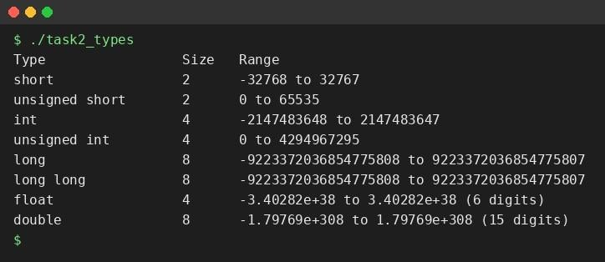
Figure 2.1 — sizeof and ranges of each type.
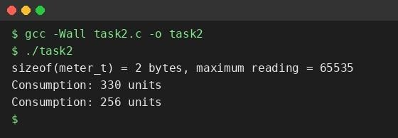
Figure 2.2 — Rollover test: consumption(1200,1530)=330 and consumption(65400,120)=256.
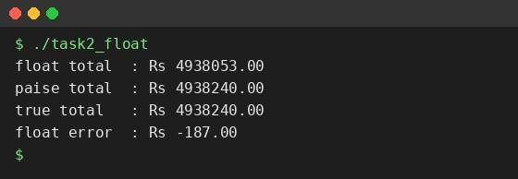
Figure 2.3 — 4,000 bills of Rs 1234.56: float total is wrong by Rs 187; paise total is exact.

Analysis / Discussion
- Why 256 and not negative. From reading 65400, the register counts 65400→65535 (135 steps), then 65535→0 (1 step), then 0→120 (120 steps): 135 + 1 + 120 = 256. In C, current − previous is evaluated in int as 120 − 65400 = −65280; converting back to unsigned short takes the value modulo 65536:
−65280 + 65536 = 256. The same formula gives 330 when there is no rollover, so no if–else is needed. Because meter_t is unsigned, the result can never be a negative number.
- After 65535. A 16-bit unsigned register has no larger value; the next count wraps around to 0.
- Why not float rupees. A float stores binary fractions, so 1234.56 is only approximately held, and with about 7 significant digits the running total loses small additions once it is in the millions. Adding Rs 1234.56 4,000 times gave Rs 4,938,053.00 instead of Rs 4,938,240.00 — an error of Rs 187. Storing 123456 paise in a long gives the exact total, because integer addition has no rounding.
- Is the range enough for a district? Yes: even Rs 10,000 per bill for 10 million households is 10^13 paise, far below 9.2×10^18. Only a 32-bit int (2.1×10^9 paise = Rs 2.1 crore) would be unsafe.

Alternative Concept and Complexity Analysis
If money were stored as double rupees, a bill would be computed as units × rate in rupees (for example 150
→ 50 + 50×2.25), and rounding would have to be applied explicitly — once, at the end, with round(x ×
100)/100, or when printing with %.2f — so that cents are not lost or shown wrongly. Each addition is O(1) in both representations. Space: a double needs 8 bytes and a long needs 8 bytes (same here); a float needs 4 bytes but is the least accurate.
 | double rupees | long paise
Time per addition | O(1) | O(1)
Space per value | 8 bytes | 8 bytes
Rounding | Each add may round; must be rounded to 2 decimals at the end | None — exact integers
Error after n bills | Grows with n: worst case about n × ε × total, roughly O(n) (random errors about O(√n)) | Zero for any n (until overflow)

Result
Suitable types were selected and verified with sizeof and the limits headers. consumption() produced 330 and 256 units exactly as expected, without if–else, and float was shown to give an incorrect total (Rs 187 short) where paise in a long are exact.

TASK 3 — Define the Constants

Task / Problem Statement
Define the tariff values and limits as constants so that a tariff revision is made in one place only, and complete TODO 1 of compute_bill() using only the macros defined at the top of the program.

Aim
To use #define constants (with a comparison to const variables and enum) so the tariff can be changed in a single place and every bill stays consistent.

Concept / Theory
- #define is replaced by the preprocessor with its text before compilation. It has no type, no storage and no scope; it is good for numeric tariff values and array sizes.
- const variable is a real object with a type, scope and (usually) storage; the compiler type-checks it and a debugger can show it.
- enum creates named integer constants (int-valued), ideal for related whole-number codes such as category or slab numbers.
- Naming convention: constants are written in UPPER_CASE with underscores and carry the unit in the name (RATE2_PAISE, FIXED_CHARGE_PAISE) so that nobody mixes rupees and paise. The suffix L on 5000L makes the constant a long.
 | #define | const variable
Type checking | None — plain text substitution | Yes — compiler checks the type
Scope | From the #define to end of file (ignores blocks) | Normal block / file scope
Debugging | Name not visible in debugger (replaced earlier) | Name and value visible in debugger
Storage | None | May use memory (may be optimised away)

Procedure / Algorithm
- Define the slab limits, the three rates and the fixed charge as macros at the top.
- Start the bill with paise = FIXED_CHARGE_PAISE.
- Add units above SLAB2_UNITS at RATE3_PAISE.
- Add units from SLAB1_UNITS+1 up to SLAB2_UNITS at RATE2_PAISE.
- Add the remaining first-slab units at RATE1_PAISE (0).
- Return the total in paise; print it as rupees.paise using / 100 and % 100.

Program / Source Code
#include <stdio.h>
#define SLAB1_UNITS 100 /* first 100 units */ #define SLAB2_UNITS 200 /* units 101 to 200 */ #define RATE1_PAISE 0 /* first slab is free */
#define RATE2_PAISE 225 /* Rs 2.25 per unit */
#define RATE3_PAISE 450 /* Rs 4.50 per unit above 200 */
#define FIXED_CHARGE_PAISE 5000L /* Rs 50 fixed charge */
/* Returns the bill in paise, so that no rounding error can occur. */ long compute_bill(int units)
{
long paise = FIXED_CHARGE_PAISE; if (units > SLAB2_UNITS) paise += (long)(units - SLAB2_UNITS) * RATE3_PAISE; if (units > SLAB1_UNITS) { int in_slab2 = (units > SLAB2_UNITS ? SLAB2_UNITS : units) - SLAB1_UNITS; paise += (long)in_slab2 * RATE2_PAISE;
} int in_slab1 = units > SLAB1_UNITS ? SLAB1_UNITS : units; paise += (long)in_slab1 * RATE1_PAISE; return paise;
} int main(void)
{
int tests[] = {0, 100, 150, 200, 350}; int n = sizeof tests / sizeof tests[0]; for (int i = 0; i < n; i++) { long p = compute_bill(tests[i]); printf("%3d units -> Rs %ld.%02ld\n", tests[i], p / 100, p % 100);
}
return 0;
}

Output Screenshot
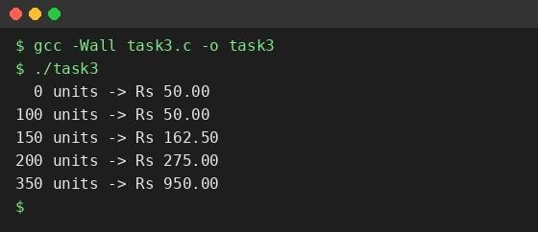
Figure 3.1 — Output with RATE2_PAISE = 225 (matches the expected output).
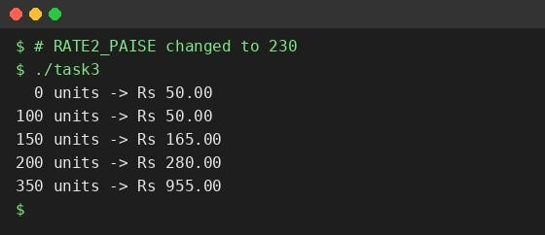
Figure 3.2 — Output after changing only RATE2_PAISE to 230.

Analysis / Discussion
- Check, 150 units: 5000 + 50 × 225 = 16250 paise = Rs 162.50. 350 units: 5000 + 100 × 225 + 150 × 450 = 5000 + 22500 + 67500 = 95000 = Rs 950.00. Both match the expected output.
- After changing only RATE2_PAISE to 230, only bills that include slab 2 changed, and by exactly 5 paise per slab-2 unit: 150 units → Rs 165.00 (+2.50, 50 units), 200 units → Rs 280.00 (+5.00, 100 units), 350 units → Rs 955.00 (+5.00). Bills at 0 and 100 units stayed Rs 50.00 because they use no slab-2 units. No other line of code was edited, so the tariff revision was made in one place.
- Boundaries are consistent: units exactly 100 and 200 fall in the lower slab, and the bill is continuous and never decreases.
- Using paise in a long makes the whole calculation integer-only, so there is no rounding error.

Alternative Concept and Complexity Analysis
If the constants were const int variables or an enum, the program logic would remain the same; only the declarations would change (const int RATE2_PAISE = 225;, or enum { SLAB1_UNITS = 100, SLAB2_UNITS = 200, RATE2_PAISE = 225 };). An enum can only hold int values, so FIXED_CHARGE_PAISE 5000L (long) would stay a const long. Type checking would improve for const variables (a wrong type is reported), the names would be visible in the debugger, but they may occupy a few bytes of memory each. A #define occupies no storage.
 | #define | const | enum
Type checking | No | Yes | Only int
Debugger | Not visible | Visible | Visible
Memory | None | May use bytes | None (compile-time)
Running time | Same | Same | Same
Running time is not affected: the compiler substitutes or folds all these constants at compile time, so compute_bill() performs the same few operations, O(1). Only the memory (a few bytes per const) and the debugging convenience differ.

Result
A single, well-named set of constants was defined; compute_bill() uses only those macros and produced the expected bills. Changing RATE2_PAISE to 230 updated every affected bill consistently. For tariff values, #define (or enum for int codes) is a reasonable choice; const is preferable where type safety and debugging matter.

TASK 4 — Use Macros Safely

Task / Problem Statement
Write macros for small repeated calculations (converting rupees to paise, finding the larger of two values, squaring), demonstrate with gcc -E how they are expanded, and explain the common macro pitfalls and when a function is better.

Aim
To write correct, fully parenthesised macros and to understand the pitfalls of macro expansion (operator precedence and double evaluation of arguments).

Concept / Theory
A function-like macro is expanded by the preprocessor as text, before compilation: the argument text is pasted into the body without evaluating it. Because there is no evaluation or type checking at that stage, operator precedence of the pasted text and repeated use of a parameter cause errors. The rules are: parenthesise every parameter and the whole body, and avoid passing expressions with side effects (i++).

Procedure / Algorithm
- Define RUPEES_TO_PAISE, SQUARE and MAX with every parameter and the whole body in parentheses.
- Define an unsafe BAD_SQUARE(x) as x * x to show the problem.
- Use gcc -E to view the expanded code.
- Call MAX(i++, j) to show double evaluation, and compare with an inline function.
- Compile, run, and record the results.

Program / Source Code
#include <stdio.h>

#define RUPEES_TO_PAISE(r) ((r) *
100L)

#define SQUARE(x) ((x) * (x))
#define BAD_SQUARE(x) x * x

#define MAX(a, b) ((a) > (b) ? (a) : (b))

static inline int max_fn(int a, int b) { return a > b ? a : b; }

static inline long square_fn(long x) { return x *
x; }

int main(void)

{

int a = 4;

printf("BAD_SQUARE(a+1) = %d (expected 25)
\
n", BAD_SQUARE(a+1));

printf("SQUARE(a+1) = %ld
\
n", (long)SQUARE(a+1));
printf("RUPEES_TO_PAISE(50) = %ld
\
n", RUPEES_TO_PAISE(50));

int i = 5, j = 3;

int m = MAX(i++, j);

printf("MAX(i++, j), i=5, j=3: m = %d, i = %d
\
n", m, i);

i = 7; j = 3;
m = MAX(i++, j);

printf("MAX(i++, j), i=7, j=3: m = %d, i = %d
\
n", m, i);

i = 7; j = 3; m
=
max_fn(i++, j);

printf("max_fn(i++, j), i=7, j=3: m = %d, i = %d
\
n", m, i);

printf("square_fn(a+1) = %ld
\
n", square_fn(a+1));

return 0;

}

Output Screenshot
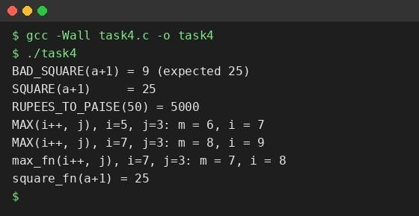
Figure 4.1 — Program output.
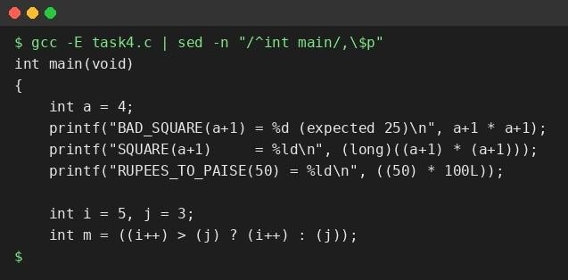
Figure 4.2 — gcc -E output showing the macro expansions inside main().

Analysis / Discussion
- Expansion (gcc -E). The preprocessor replaced BAD_SQUARE(a+1) with a+1 * a+1, SQUARE(a+1) with ((a+1) * (a+1)), and MAX(i++, j) with ((i++) > (j) ? (i++) : (j)).
- SQUARE(a+1) pitfall. a+1 * a+1 is evaluated with precedence as a + (1*a) + 1 = 4 + 4 + 1 = 9, not 25. With parentheses, ((a+1) * (a+1)) = 5 × 5 = 25.
- MAX(i++, j) pitfall. The macro uses the parameter twice: once in the test and once as the result, so i+ + is executed twice. With i = 5, j = 3 the result was 6 (not 5) and i became 7 (not 6); with i = 7 the result was 8 and i became 9. The function max_fn(i++, j) evaluates its argument once and returned 7 with i = 8.
- Why the extra outer parentheses. Without them, 100 / SQUARE(2) style expressions could regroup incorrectly.
- When a function is better. When arguments may have side effects, when type checking is wanted, when the body is more than one short expression, when debugging/stepping is needed, or when the same code would be copied many times. A macro is acceptable for tiny constant-like expressions where the arguments are simple.

Alternative Concept and Complexity Analysis
If MAX and SQUARE were replaced by static inline functions (static inline int max_fn(int a, int b); static inline long square_fn(long x);), each argument is evaluated exactly once, is type-checked, and appears in the debugger. A real (non-inlined) call costs O(1) extra time (pushing arguments, call and return, a few cycles), while an expanded macro has no call overhead; but with optimisation the compiler normally inlines small static inline functions, so the speed is practically the same.
 | Macro | static inline function
Time per use | O(1), no call overhead | O(1); small call cost unless inlined (usually inlined)
Code size, k uses | O(k × body): body copied at every use | O(body) if called; O(k × body) if inlined
Arguments | Evaluated as text, may repeat | Evaluated once
Type checking | None | Yes

Result
Fully parenthesised macros were written and expanded with gcc -E. The pitfalls of precedence (SQUARE(a+1)) and double evaluation (MAX(i++, j)) were demonstrated, and shown to be avoided by parentheses or by an inline function.

Test Cases / Validation Table

Record different inputs, expected results, actual results, and whether each test passed.
Test No. | Input / Scenario | Expected Output | Actual Output | Status
1 | consumption(1200, 1530) (no rollover) | 330 units | 330 units | Pass
2 | consumption(65400, 120) (rollover) | 256 units | 256 units | Pass
3 | compute_bill(0) | Rs 50.00 | Rs 50.00 | Pass
4 | compute_bill(150) | Rs 162.50 | Rs 162.50 | Pass
5 | compute_bill(350) | Rs 950.00 | Rs 950.00 | Pass
6 | SQUARE(a+1), a = 4 | 25 | 25 | Pass
7 | compute_bill(150) after RATE2_PAISE = 230 | Rs 165.00 | Rs 165.00 | Pass
8 | 4,000 bills of Rs 1234.56 stored in paise | Rs 4938240.00 | Rs 4938240.00 | Pass

Final Submission Checklist

☐ Student and course details completed (fill in name, register number and slot)
☐ Task statement, aim, theory, and algorithm included
☐ Program code is readable and runs successfully
☐ Output screenshot included
☐ Analysis and result written in own words
☐ Test cases completed where applicable
☐ GitHub repository link added if required

